Student Name: __________________
Class and Section __________________
Total Points (20 pts) __________________
Due: March 21, 2011 before the class

Project: Hangman

CSCI 2410 Data Structures and Algorithms
Armstrong Atlantic State University

Team Project: Form a team with 2 or 3 members. Each member needs to submit it online. Submit one hard copy for the team.

Team members: ________________________

Problem Description:

(Game: hangman) Write a GUI program that lets a user play the hangman game. The user guesses a word by entering one letter at a time, as shown in Figure 16.33. If the user misses seven times, a hanging man swings, as shown in Figure 16.33b-c. Once a word is finished, the user can press the Enter key to continue to guess another word.

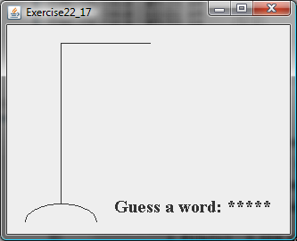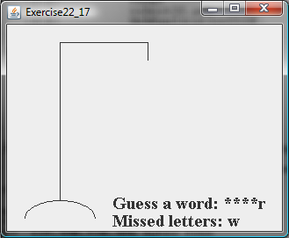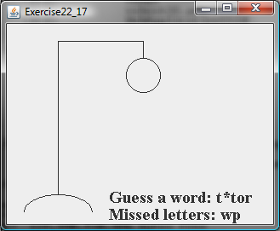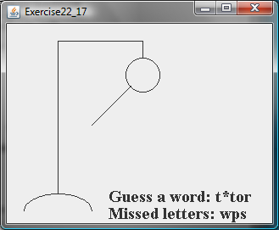
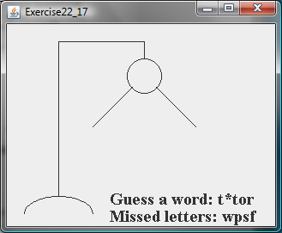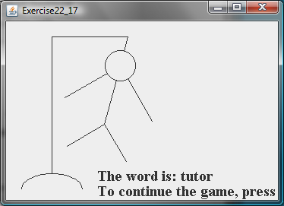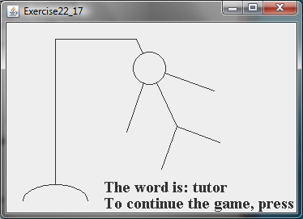
Figure 22.23
The program plays a hangman game.

Your program needs to read the words from http://www.cs.armstrong.edu/liang/hangman.txt.

Requirements:

Analysis:
(Describe the problem including input and output in your own words.)

Design:
(Describe the major steps for solving the problem)

Coding: (Copy and Paste Source Code here. Format your code using Courier 10pts)
Name the public class Exercise21_17

Testing: (Describe how you test this program)

Screen Shot

What to submit?

1. This document for the team

2. Compile and Submit to LiveLab (each team member must submit the program regardless whether it complete or incomplete, correct or incorrect)

3. Fill in self-evaluation:

- Can your program read the words from the URL? _______________
- Can your program display the initial user interface? _______________
- Can your program receive a character from the user? _______________
- Can your program check if the character is in the hidden word? ___________
- Can your program count the number of misses? ___________
- Can your program display the hangman incrementally? ___________
- Can your program display a hangman swing? ___________
- Can your program start over with a new guess? _______________

